Συστήματα Αναμονής (Queuing Systems)

3ο Εργαστήριο
Θοδωρής Παπαρρηγόπουλος (el18040)

Ερώτηση 1)

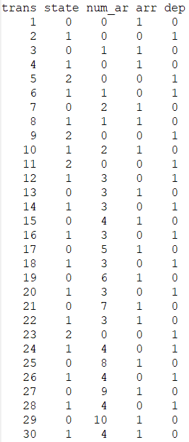
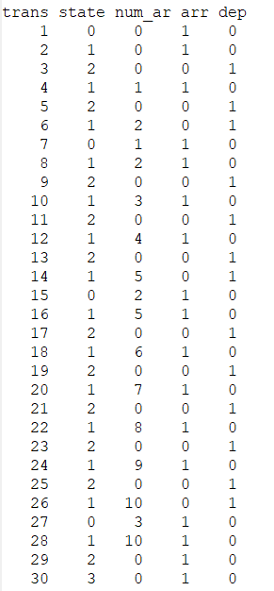
Για λ = 1 Για λ = 5 Γιο λ = 10
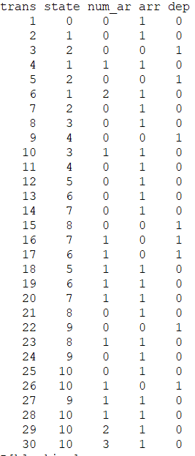

Ερώτηση 2)

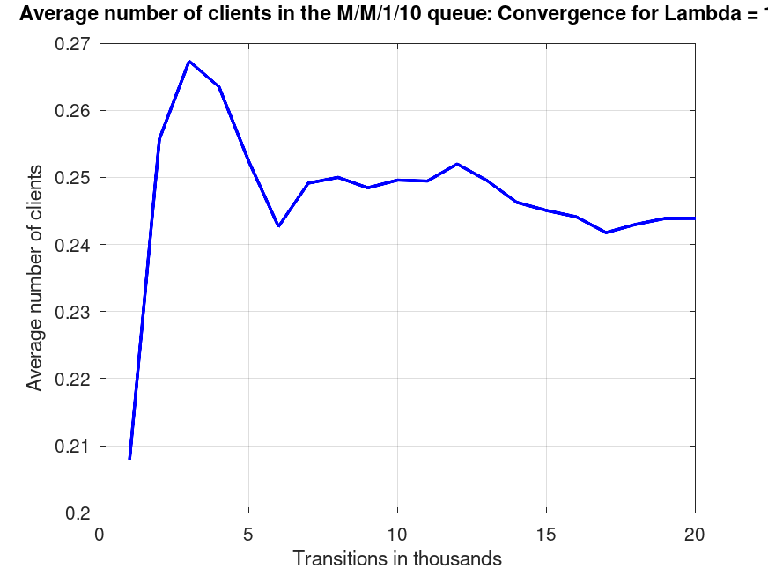
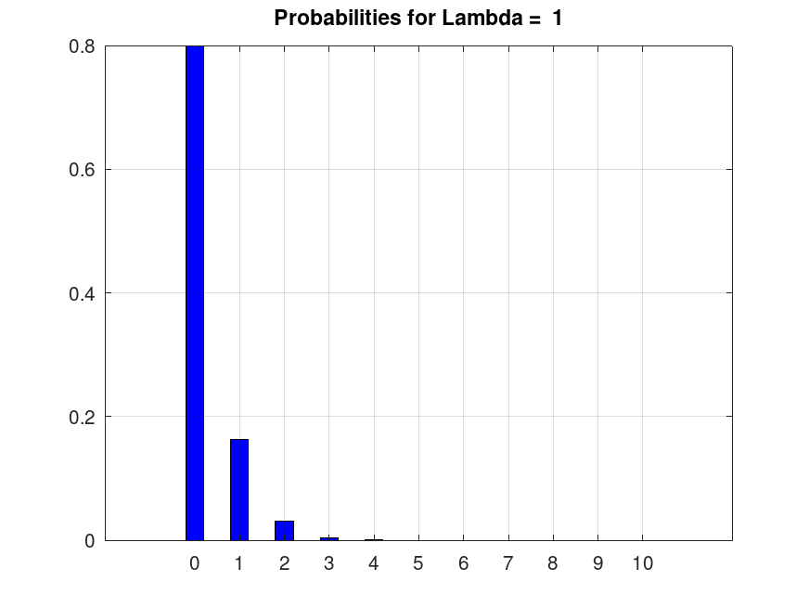
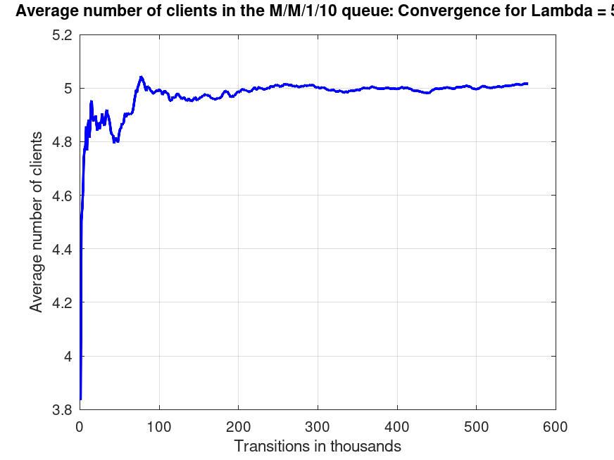
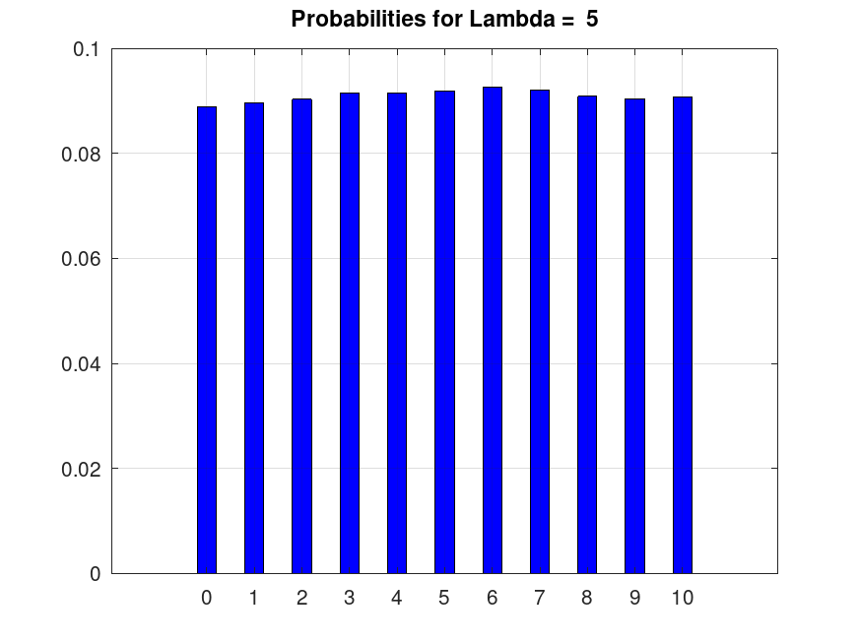
5
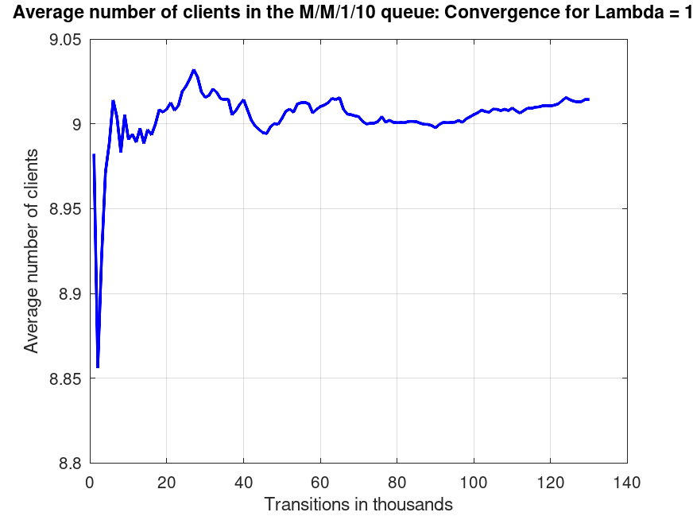
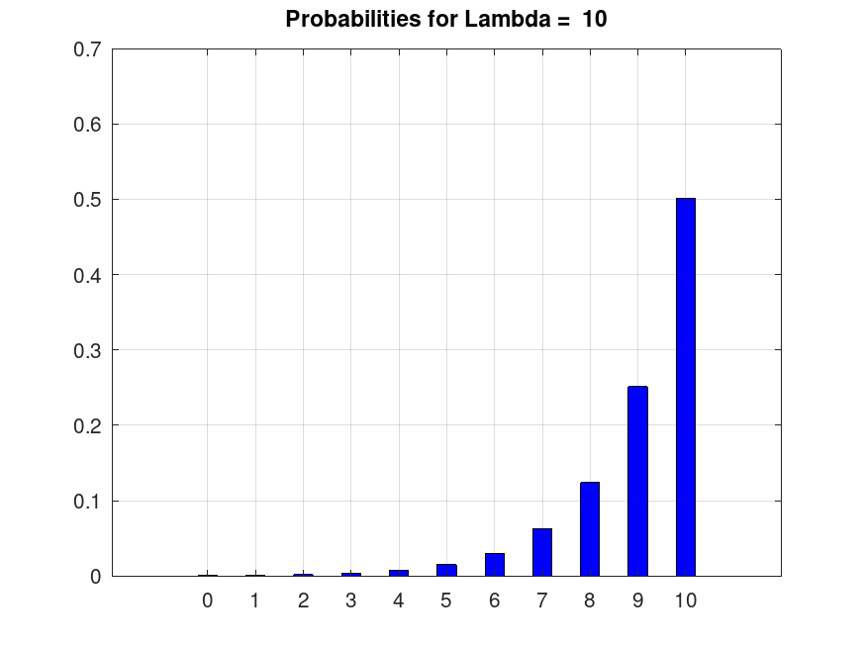
0
Ερώτηση 3)

Παρατηρούμε πως γιαόσο το ε αυξάνει, τότε αυξάνεται και η σύγκλιση. Ο αριθμός το transitions που μπορούμε να αγνοήσουμε εξαρτάτε στο λ που εξαρτάτε στο ε. Έτσι όσο μεγαλύτερο ε τόσο μικρότερο αριθμό μπορούμε να αγνοήσουμε. Έτσι για τα 3 λ μπορούμε να αγνοήσουμε τουλάχιστον 20κ – 50κ transitions.

Ερώτηση 4)

Εάν είχαμεμε(i=1,2,3…,10) τότε θα έπρεπε σε κάθε μετάβαση να αλλάζουμε το threshold με βάση το state στο οποίο είμαστε, δηλαδή θα έπρεπε (έστω πως είμαστε στην κατάσταση.

Κώδικας

% M/M/1 simulation. We will find the probabilities of the first states.
% Note: Due to ergodicity, every state has a probability >0.

clc;
clear all;
close all;

figure_counter = 0;
rand('seed',12163);

for lambda = [1,5,10]
arrivals = [0,0,0,0,0,0,0,0,0,0,0]
mu = 5;
total_arrivals = 0; % to measure the total number of arrivals
current_state = 0; % holds the current state of the system
previous_mean_clients = 0; % will help in the convergence test
index = 0;
threshold = lambda/(lambda + mu); % the threshold used to calculate probabilities

transitions = 0; % holds the transitions of the simulation in transitions steps
tracem_i = 0;
tracem = [];
to_plot = [];
while transitions >= 0
transitions = transitions + 1; % one more transitions step

tracem_i = tracem_i + 1;
if tracem_i > 0 && tracem_i < 31 %&& current_state > 0
tracem(tracem_i,1) = tracem_i;
tracem(tracem_i,2) = current_state;
tracem(tracem_i,3) = arrivals(current_state+1);
endif

if mod(transitions,1000) == 0 % check for convergence every 1000 transitions steps
index = index + 1;
for i=1:1:length(arrivals)
P(i) = arrivals(i)/total_arrivals; % calculate the probability of every state in the system
endfor

mean_clients = 0; % calculate the mean number of clients in the system
for i=1:1:length(arrivals)
mean_clients = mean_clients + (i-1).*P(i);
endfor

to_plot(index) = mean_clients;

if abs(mean_clients - previous_mean_clients) < 0.00001 || transitions > 1000000 % convergence test
break;
endif

previous_mean_clients = mean_clients;

endif

random_number = rand(1); % generate a random number (Uniform distribution)
if current_state == 0 || random_number < threshold % arrival
%{
if 0 < tracem_i < 31
tracem(tracem_i,4) = 1
%disp("arrival"), disp(current_state);
endif
%}
total_arrivals = total_arrivals + 1;
% to catch the exception if variable arrivals(i) is undefined. Required only for systems with finite capacity.
x = arrivals(current_state + 1) + 1;
arrivals(current_state + 1) = x; % increase the number of arrivals in the current state
if (current_state != 10)
current_state = current_state + 1;
endif
else % departure
%{
if 0 < tracem_i < 31
tracem(tracem_i,5) = 1
endif
%}
if current_state != 0 % no departure from an empty system
current_state = current_state - 1;
endif
endif

endwhile

for i=1:1:length(arrivals)
display(P(i));
endfor

figure_counter += 1;
figure(figure_counter);
plot(to_plot,"b","linewidth",2);
title(strjoin({"Average number of clients in the M/M/1/10 queue: Convergence for Lambda = ",num2str((lambda))},""));
xlabel("Transitions in thousands");
ylabel("Average number of clients");
grid on;
saveas (figure_counter, strjoin({"figure_",num2str(1),"_lambda_",num2str((lambda)),".png"}))

figure_counter += 1;
figure(figure_counter);
bar(0:1:(length(arrivals)-1),P,'b',0.4);
title(strjoin({"Probabilities for Lambda = ",num2str((lambda))}));
grid on;
saveas (figure_counter, strjoin({"figure_",num2str(2),"_lambda_",num2str((lambda)),".png"}))

disp("trans state num_ar arr dep");
disp(tracem);

endfor

